
KL4030 Based 3&4Axis CNC Packages
Simplified Wiring Diagram

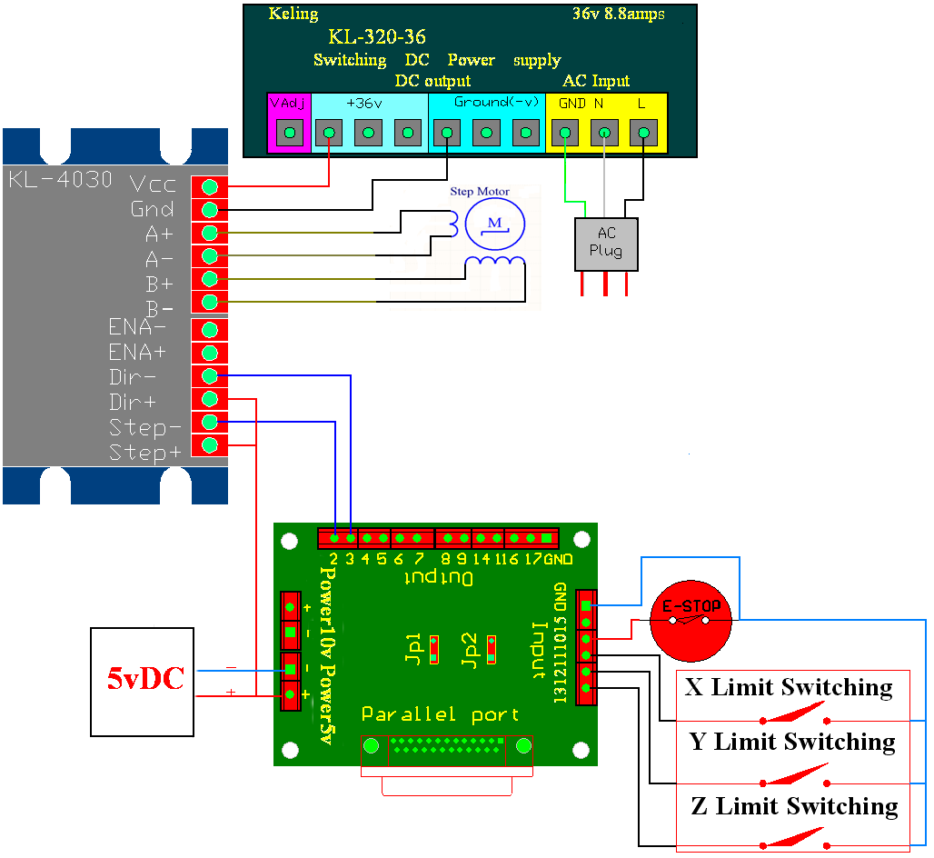
Parallel Port IO
This can be very sysem specific,but for a common 3-axis parall port controlled CNC device,the following chart can be a starting point.
Pn | Direction | Purpose
1 | Output | Spindle Control Relay
2 | Output | X Step
3 | Output | X Direction
4 | Output | Y Step
5 | Output | Y Direction
6 | Output | Z Step
7 | Output | Z Direction
10 | Input | E-Stop
11 | Input | Limit X
12 | Input | Limit Y
13 | Input | Limit Z

Wiring
JP1 and Jp2 are used to selects the 5v power supply or 10v power supply.When you uesd 5v power supply,you must Plug JP1 and JP2.else you must pull out the JP1 and JP2.

EU AC Wire Colors
Ground, or Earth is always Green/Yellow
Live is Always Brown
Neutral is Blue
US AC Wire Colors
Ground, or Earth is Usually Green
Live is usuall Black
Neutral is usually White

